**WEEK-4**

**#1 Write a C++ program to check whether a number is even or odd using ternary operator.**

This is the required code with the result

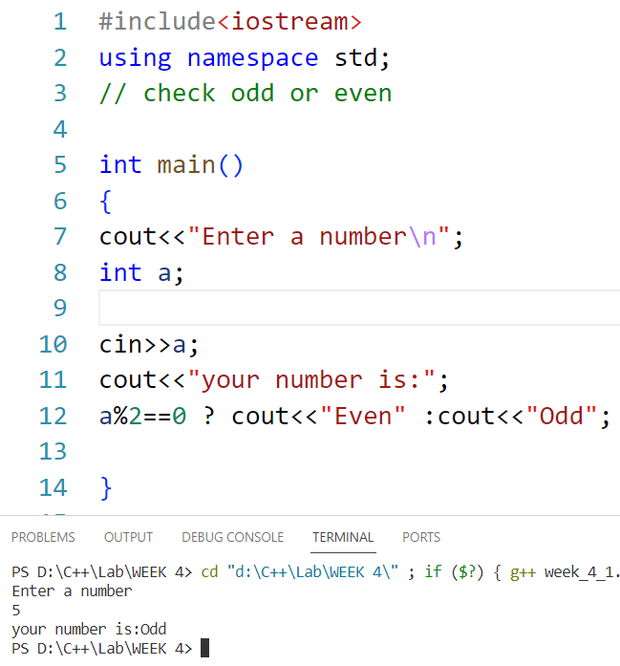

**#2 Write a C++ program to perform the addition of two numbers without using ‘+’ operators.**

This is the required code:

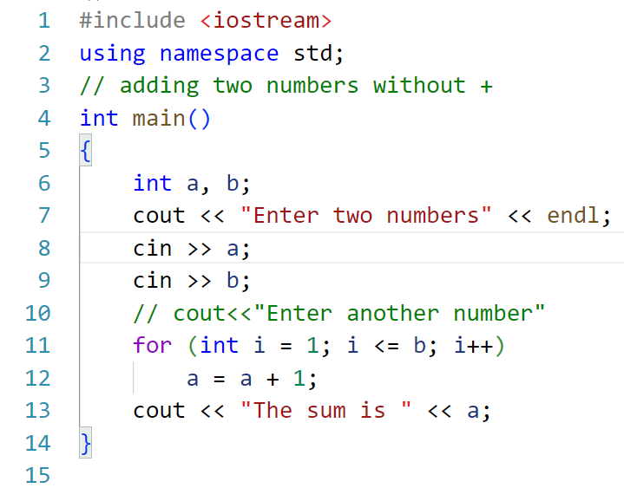

And this is the result:

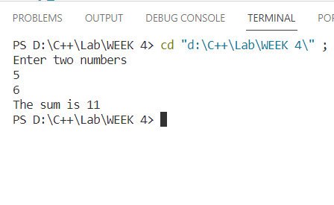

**#3 Write a C++ program to evaluate the arithmetic expression ((a+b/c*d-e)*(f-g)). Read the values a, b, c, d, e, f, g from the standard input device.**

The required code for the given program is given below:

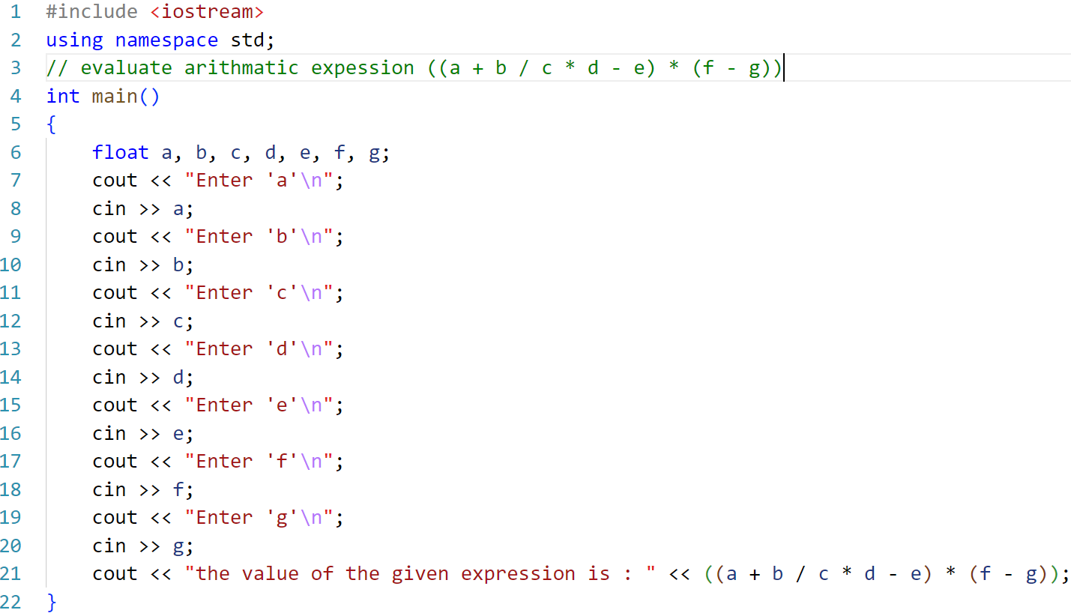

And its result is:

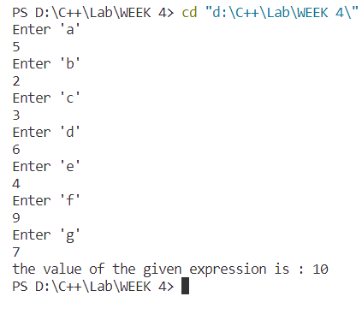

**#4 A Fibonacci sequence is defined as follows, the first and second terms in the sequence are 0 and 1. Subsequent terms are found by adding the preceding two terms in the sequence. Write a C++ program to generate the first n terms of the sequence.**

This is the required code for Fibonacci sequence:

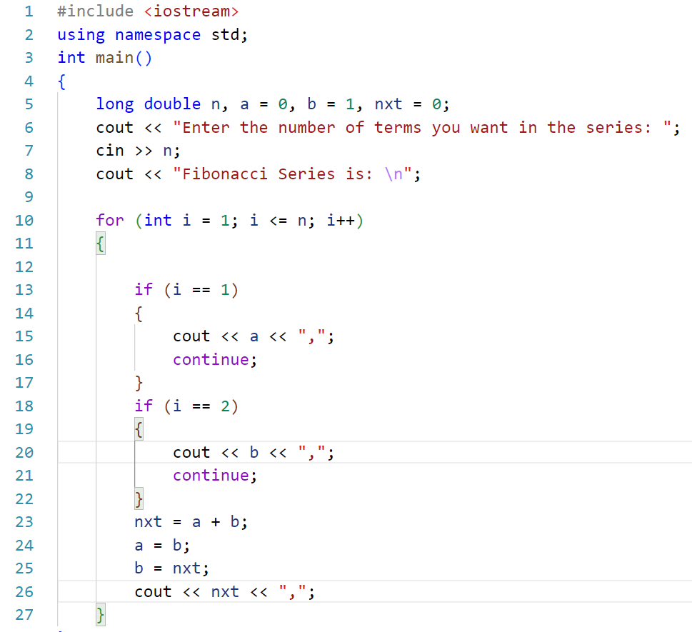

The result is:

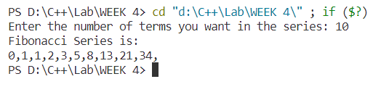

**#5 Write a C++ program to generate all the prime numbers between 1 and n, where n is the value supplied by the user.**

This is the required cod:

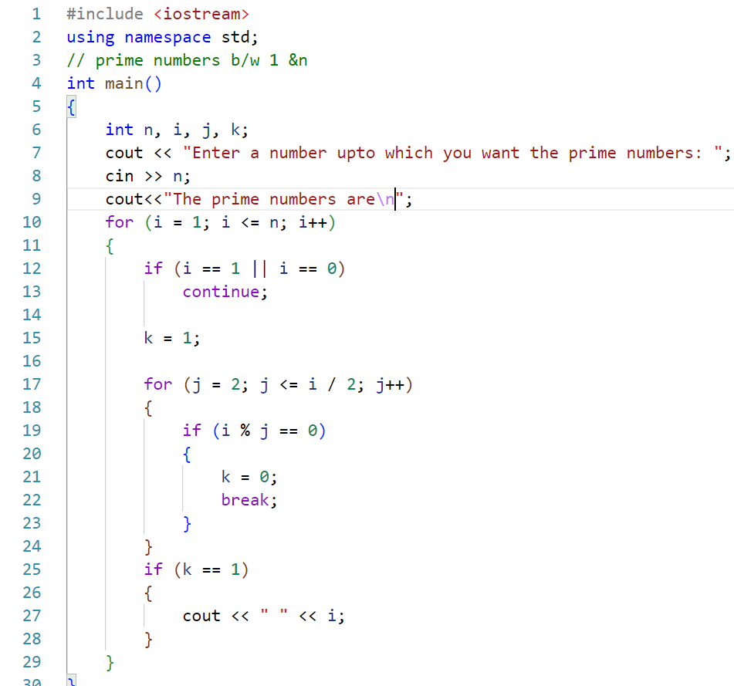

And it’s result is:

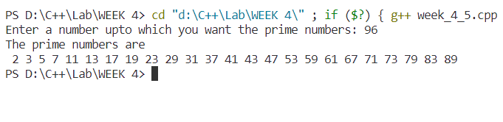

**#6 A character is entered through keyboard. Write a C++ program to determine whether the character entered is a capital letter, a small case letter, a digit or a special symbol using if-else and switch case. The following table shows the range of ASCII values for various characters.**

**Characters**

**ASC**II **A-Z, 65-90, a-z, 97-122, 0-9, 48-57**

**Special symbols 0-47, 58-64, 91-96, 123-127**

This is the required code:

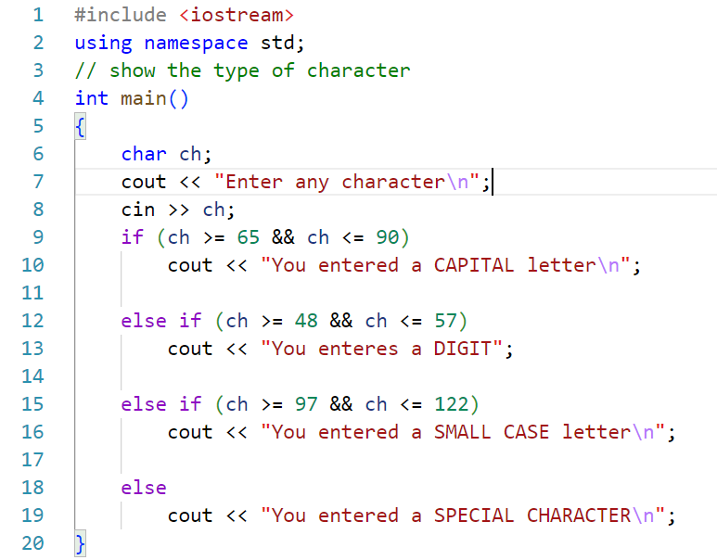

And it’s results are:

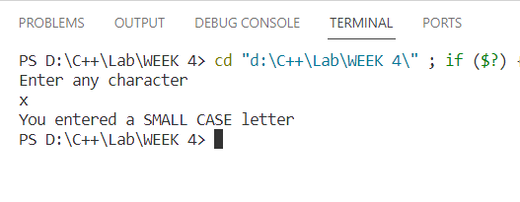

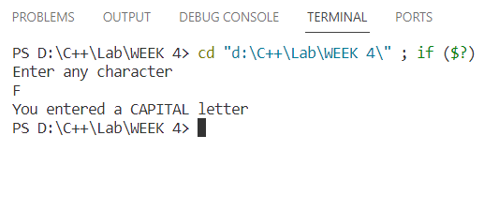

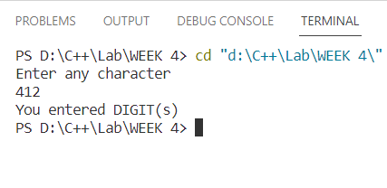

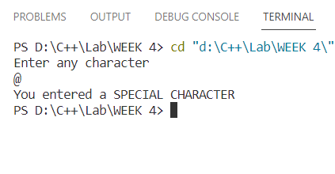

**#7 Write a C++ program to find the roots of a equation.**

This is the required code:

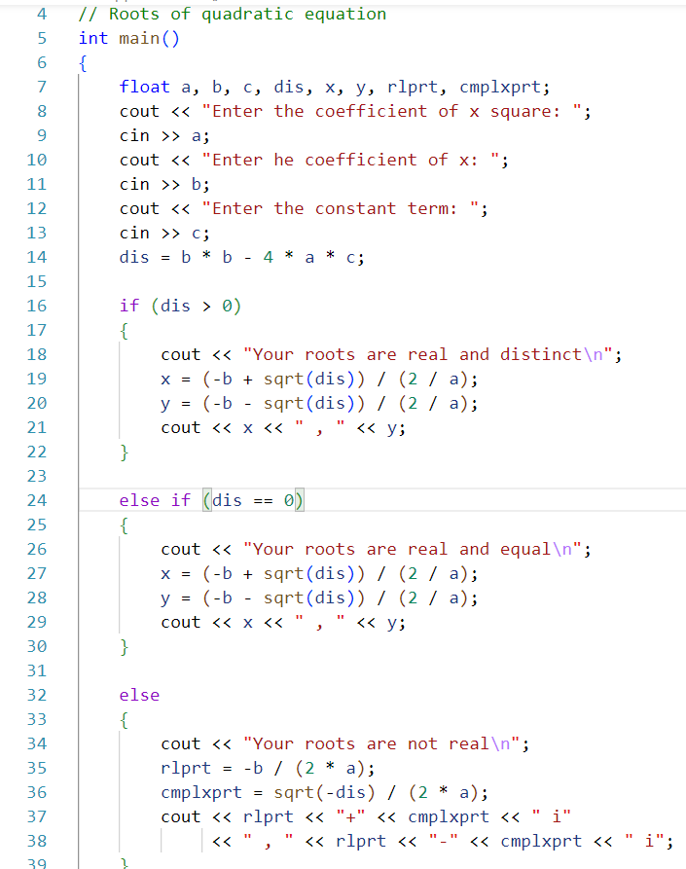

This is it’s result:

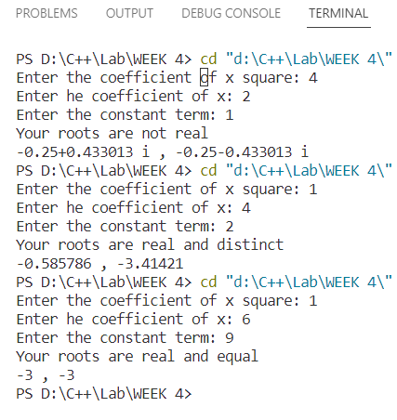

**#8 Write a program to check whether a given 3 digit number is Armstrong number or not.**

This is the required code:

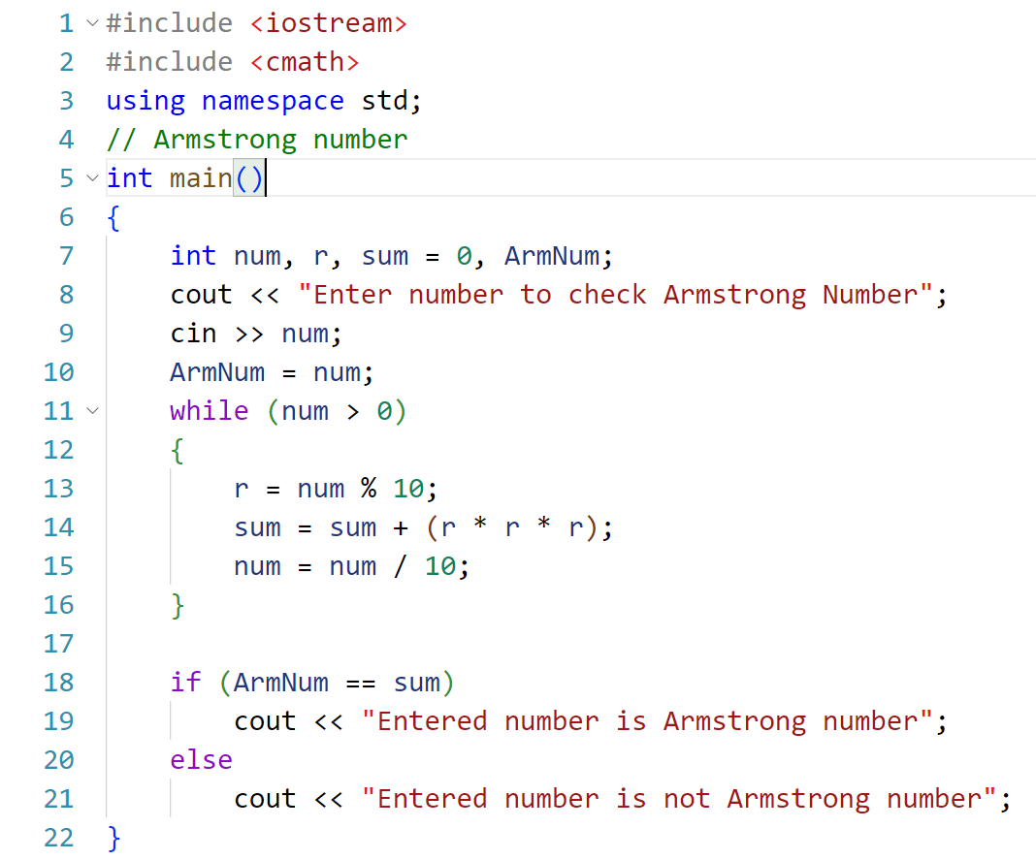

This is the result:

